Objective probability based on statistics, experiments, and mathematical measurements. Subjective probability is based on personal feelings, experience, or judgment.
Objective probability
Data professionals use objective probability to analyze and interpret data. There are two types of objective probability: classical and empirical.
Classical probability is based on formal reasoning about events with equally likely outcomes. 
Empirical probability is based on experimental or historical data; it represents the likelihood of an event occurring based on the previous results of an experiment or past events. 
Inferential statistics uses probability too. For instance, a retail company might survey a representative sample of 100 customers to predict the shopping preferences of all their customers. Data professionals rely on empirical probability to help them make accurate predictions based on sample data.
subjective probability
The results of are based on personal feeling, experience, or judgment. This type of probability does not involve formal calculations, statistical analysis, or scientific experiments.
For example, the CEO of an auto company might feel confident that using a new technology to manufacture their pickup truck will cut costs and increase profits. But if their prediction is only based on personal feeling or subjective probability, it may not be reliable. Data science based on statistical analysis or objective probability can help accurately predict the potential impact of the new technology and help the CEO make an informed, data-driven decision about adopting the technology.
Principles
The probability that an event will occur is expressed as a number between 0 and 1. If the probability of an event equals zero, there's a zero percent chance that the event will occur. If the probability of an event equals one, there's a 100 percent chance that the event will occur. There are lots of possibilities in between 0 and 1. If the probability of an event equals 0.5, there is a 50 percent chance that the event will occur or not occur. If the probability of an event is close to zero, there's a small chance that the event will occur. If the probability of an event is close to one, there's a strong chance that the event will occur.
A random experiment is a process whose outcome cannot be predicted with certainty. All random experiments have three things in common. The experiment can have more than one possible outcome, you can represent each possible outcome in advance, and the outcome of the experiment depends on chance.
To calculate the probability of a random experiment, you divide the number of desired outcomes by the total number of possible outcomes. You may recall that this is also the formula for classical probability.

Basic rules
Two events are mutually exclusive if they cannot occur at the same time.
Two events are independent if the occurrence of one event does not change the probability of the other event. This means that one event does not affect the outcome of the other event.
The complement rule:
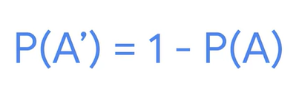
The addition rule:
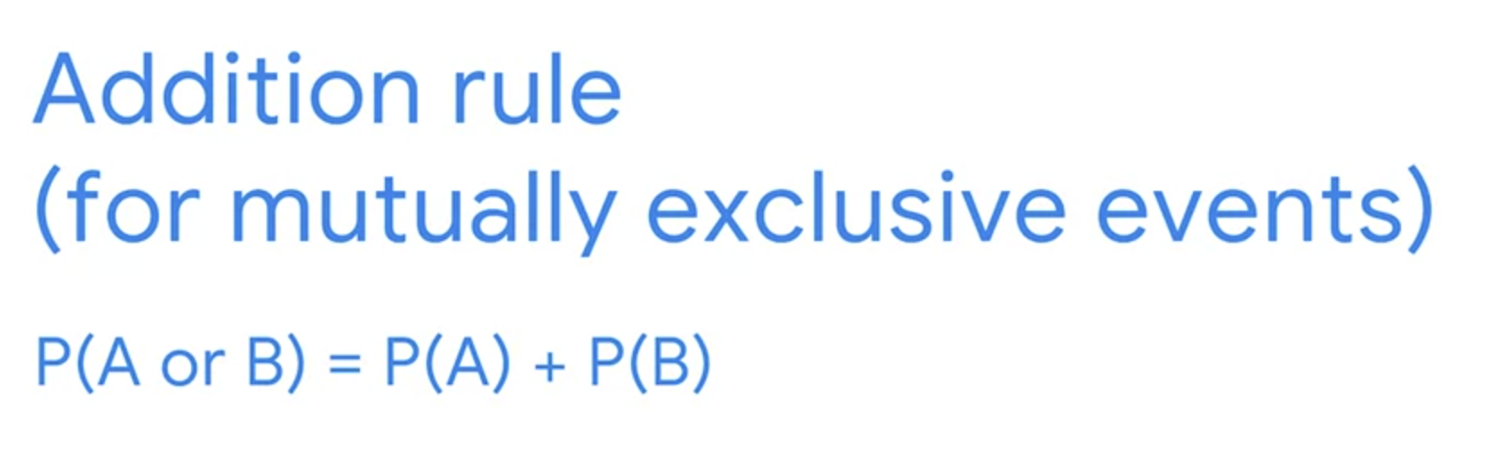

the complement rule and the addition rule, apply two events that are mutually exclusive. Two events are mutually exclusive if they cannot occur at the same time.
Say you want to find the probability of rolling either a 2 or a 4 on a single roll. These two events are mutually exclusive. You can roll a 2 or a 4, but not both at the same time.
The addition rule says that to find the probability of either event occurring, you sum up their probabilities. The odds of rolling any single number on a die are 1 out of 6, or 16.7%.
P(rolling 2 or rolling 4) = P(rolling 2) + P(rolling 4) = ⅙ + ⅙ = ⅓

The multiplication rule:
If you want to calculate probability for independent events, you can use the multiplication rule. Two events are independent if the occurrence of one event does not change the probability of the other event. This means that one event does not affect the outcome of the other event.

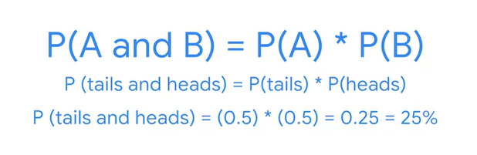
Now imagine two consecutive die rolls. Say you want to know the probability of rolling a 1 and then rolling a 6. These are independent events as the first roll does not affect the outcome of the second roll.
The probability of rolling a 1 and then a 6 is the probability of rolling a 1 multiplied by the probability of rolling a 6. The probability of each event is ⅙, or 16.7%. You can write this as:
P(rolling 1 on the first roll and rolling 6 on the second roll) = P(rolling 1 on the first roll)×P(rolling 6 on the second roll) = ⅙×⅙ = 1/36



Conditional Probability
The probability of an event occurring given that another event has already occurred.
Two events are dependent if the occurrence of one event changes the probability of the other event.
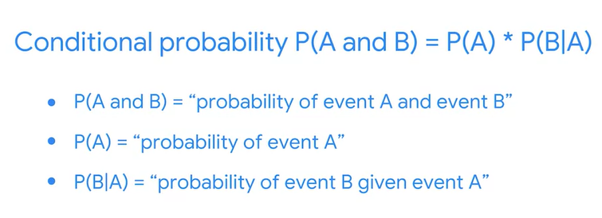
Bayes’ theorem
It provides a way to update the probability of an event based on new information about the event.
Prior probability refers to the probability of an event before new data is collected.
Posterior probability is the updated probability of an event based on new data.

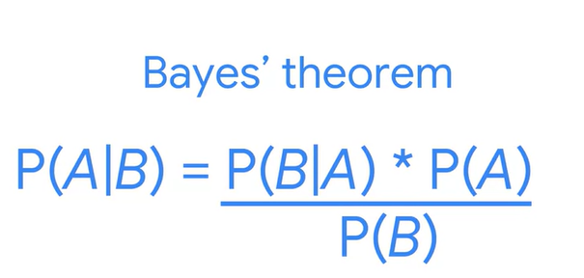
Example:
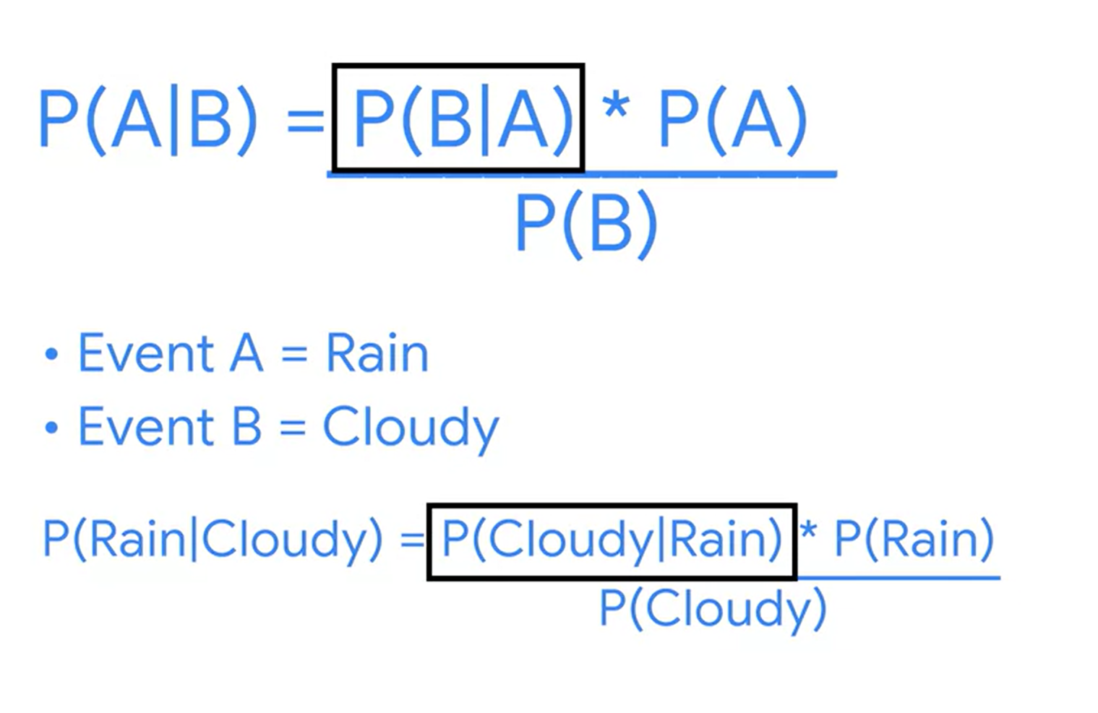
Expanded version of Bayer’s theorem
Works better
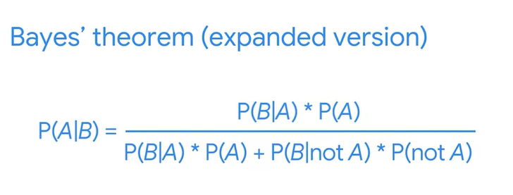
You don’t need to know probability of event B.



Discrete probability distributions
Probability distribution: describes the likelihood of the possible outcomes of a random event.
Random Variable: represents the values for the possible outcomes of a random event

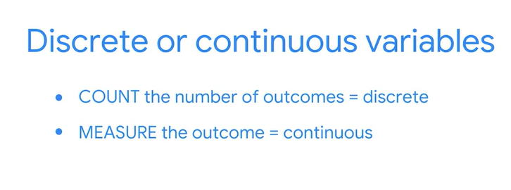
Discrete distributions represent discrete random variables
Continuous distributions represent continuous random variables

Samples space: the set of all possible values for a random variable

Binomial distribution
It is a discrete distribution that models the probability of events with only two possible outcomes, success or failure.
- Each event is independent
- The probability of success is the same for each event
- Mutually exclusive, cannot occur at the same time

Binomial experiment is a type of random experiment (recall random experiment is a process whose outcome cannot be predicted with certainty)
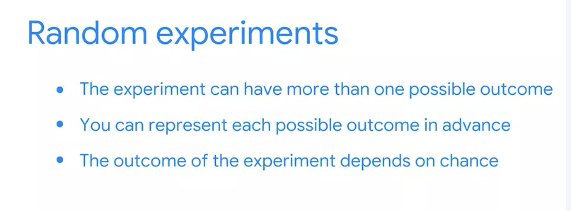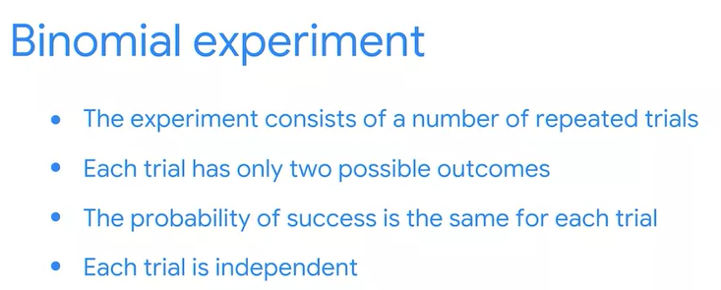

Example of binomial experiment: tossing a coin 10 times.
Example:
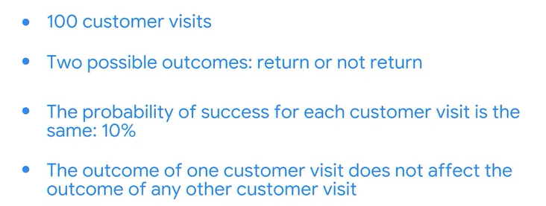

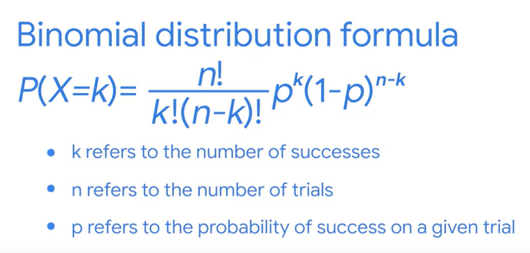

Poisson distribution
probability distribution that models the probability that a certain number of events will occur during a specific time period.
Baron Simeon Denis Poisson, French mathematician, originally derive the Poisson distribution in 1830. He developed the distribution to describe the number of times a gambler would win in difficult game of chance in a large number of tries.
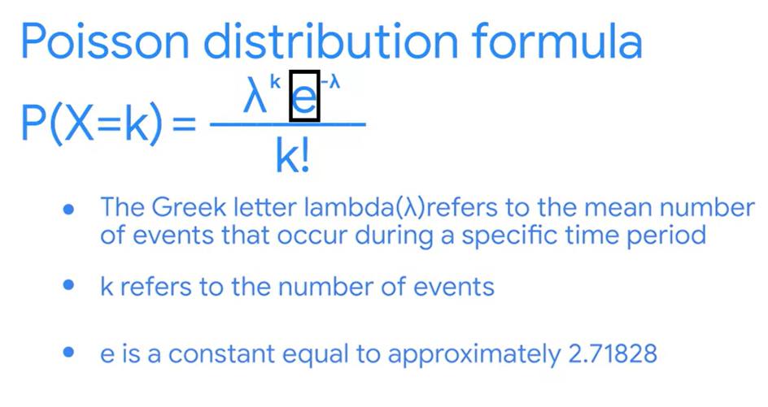
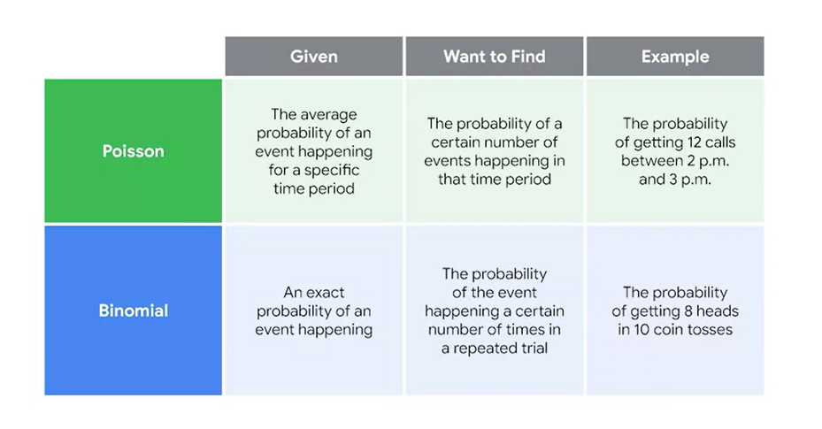
Continuous Probability distributions
Normal distribution: A continuous probability distribution that is symmetrical on both sides of the mean and bell-shaped.
The further a value is away from the mean the less likely it is to occur
All Normal distributions have the following features:
- The shape is a bell curve
- The mean is located at the center of the curve
- The curve is symmetrical on both sides of the center
- The total area under the curve equals 1
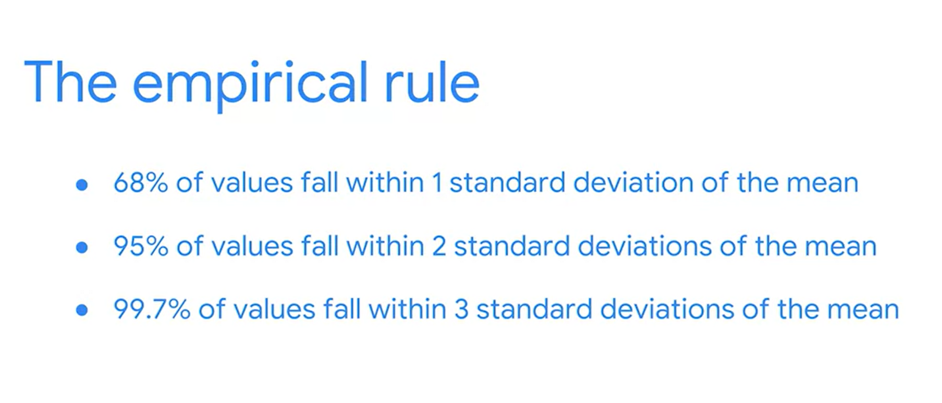
Standardize data using z-socres
A z-score is a measure of how many standard deviations below or above the population mean a data point is. A z-score gives you an idea of how far from the mean a data point is.
For example, the z-score is 0, if the value is equal to the mean. The z-score is positive if the value is greater than the mean. The z-score is negative if the value is less than the mean.
